Student’s Name
Professor’s name
Course code and name
Institutional affiliation
Date
Dred Scott vs Shelby
The Supreme case, Dred v Shelby, assists people in understanding the unfair legal systems at that time. The apex court the case and ruled in favor of the defendant clearly killing the only hope that the black Americans had to end slavery. The decision meant that Shelby was able to continue enslaving the black Americas (Herda, 1). It also meant that there would be no negro of the Africans blood would ever be recognized as an American Citizen. The role of the African Americans was to serve their masters for the rests of their lives unless the law was altered to their favor which was highly unlikely.
The supreme court decision also invalidated the compromise act of 1820. There were efforts that would strike a balance of power in the congress between slaves as well as the frees state. The objective of the Missouri compromise act allowed recognition of Missouri act as a slave state while Maine was regarded as a free state. However, the agreement was repealed by the Kansas -Nebraska Act in 1854. The fact that Maine was allowed as a state in the United states as a free state explicitly elaborates that at the end of the tunnel, there exists some light. The act also prescribed that the slave trade from the remaining Louisiana Purchase lands north of the 36º and 30’ parallel was effectively banned.
On 6th March 1857, described the landmark supreme ruling concerning Scott, a slave, who had sued his master on several occasions was not an American citizen. The supreme court decision is final since it the apex court on the land in the united states. Consequently, once a decision has been reached no revocation through an appeal can occur unless the change of law by the legislators. This is because the lower courts are required to follow the precedence set forthright by the supreme court on the similar cases brought forward for determination.
There is a popular believe that the black people in the modern United states are still affected by the legacy of the slavery. It is evidenced by the recent study (figure 1) that illustrates a wide racial and partisan gap concerning the perspectives of the slavery on the black American position in the society. The black people argue that slavery has continued to impact: Over 59 % allude that the legacy of the slavery affects the conditions of the black people in a very significant manner. Another 26 % of whites, 29 % of Hispanics and 33 % of Asians agree that slavery in the affects the position of black people in the America society in the modern world very significantly. However, the majority of the groups believe the impact is a fair amount of play.
The survey also reveals that close to 45 % of the U.S. adults believe that the country has not gone far enough in granting equal rights with the whites. However, 15 % believe that it has gone too far while 39 % believes in exact opposite and alludes it has been right. The United States is yet to make any significant progress on the issue of slavery according to 78 % of the black adults. It is in comparison with the 37 % of whites as well as 48 % of the Hispanics (Horowitz, 1).

Figure 1 survey on people’s perceptions on the slavery issue in the modern society.
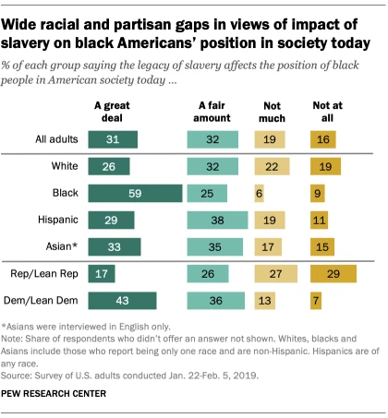
Source: https://www.pewresearch.org/fact-tank/2019/06/17/most-americans-say-the-legacy-of-slavery-still-affects-black-people-in-the-u-s-today/
There are some people’s perceptions on the subject matter regarding the United states racial progress. The black people are a bit hesitant concerning the prospects of the racial equality in the future. Majority of them allude that the country is far enough in granting the black people equal rights alongside their white counterparts. 64 % of the indicated that the country is close to achieving the racial equality. Close to 80 % of the whites are confident that at some point in future the black people and white people would have equal right (Horowitz, 1).
Comparison on party wise reveal that 80 % of the democrats and those who support its ideologies establish that are far more likely compared to 43 % of republicans and its supporters alludes that slavery still affects the situation of the black people in American society in the modern world. 66 % of the democrats and 18 % of Republicans believe that the US if far from giving the black people equal rights that the whites. In another question of the survey, 28 % of the republicans suggested that the country was moving in the right directions and another 53 % states that it has been right all through. The party’s explanation reveals that it was time to advocate for the equal rights of the black people (Horowitz, 1).
The relationship between the black America and the white Americans or other racial groups is going to the distinct the path regarding the American racial as well as the ethnic politics in the American future. However, the key concerns among the black community has always been how to unfold the relationship based on the material success as well as attachment to the American policy. It is because Increasing the complexities of the ethnic as well as racial coalitions and ethnic related policy issues would clearly derail the African – American political behavior. Although there is existence of clear patterns in both areas, the present patterns tend to be highly politically charged hence highly volatile as well as depict contingence on numerous people’s choices.
The black people should be treated more equally firm a legal standpoint in the American society. The issue of sovereignty of recognition of rights for all people regardless of color, race and gender illustrates the journey traversed to bring about sanity in the United states. The 1965 Voting Rights Act brought adept of the discriminatory practices in the US history. The Act’s developers wanted the state officials to come up with ways that would keep the minority voters away from the polls. For instance, the preclearance issue brought legal tussles thereby delaying the implementations of the changes instead of outright revocation. To ensure that black people enjoy equal rights as the white counterparts there is need to preserve some seats on the table for black people. The seats would ensure that more blacks are in positions of power like the white counterparts.
The court system should outright ensure that equality is served to the people without any form of biasness. The facts that Scott and his family were enslaved and despite looking for assistance from the corridors of justice but was denied justice. This a representation of the system can be corrupted to take away the rights other people in society. Although, the Missouri compromise of 1850 granted the couple some freedom from slavery, the supreme court opted to take again by denial the Scott who was the plaintiff his appeal prayers. At that point, it meant that the slave owners were at liberty to enslave and engage in slave trade. Scott took the case to supreme court because he and majority other people often believe that the state’s supreme court issues justices and corrects the conflicting issues in the law. Therefore, the decision to deny scot and his family right to freedom exemplified that that supreme court’s increasingly stance in pro-slavery. Furthermore, it was perceived as an opportunity to overturn the decisions of slaves that were agitated by the slavery as well as those that had benefited the slaves from seeking any form of justice in the county. The decision was purely based on the supremacy between the slave owners and slaves and their connections.
During the scot’s supreme court ruling, five of the 9 justices came from the families that held slaves’ families. This clearly meant the majority decision would take precedence and uphold Missouri supreme court which is the appellant court. The conflict of interest and unequal representation in the corridors of justice played a role in the Scot v Shelby decision. Consequently, there is need to develop laws based on the conflict of interest where the interested the parties to the issues are lawfully prevented from hearing to the matters. For instance, in this case, the five justices should not have participated in the judgement since their verdicts were already known as they could not rule against their families who were slave owners.
The black people are making tremendous progress on the political space in the modern world. This is illustrated by the fact a black American president was elected to the realm office. President Obama became the first president betting all odds. Obama stance represented a steady but slow stance for the black people space in the political sphere. In the recent decades, the black is gaining greater footage in their political leadership especially in the US house of representatives and the cabinets of recent presidents. However, they have lagged behind in the senate and governorship positions (Carter, Prudence and Sean 1).
The 2016 Pew Research suggests majority of the blacks often perceive the political representation as a catalyst for increased racial equality. About 38 % of the black adults believe that working to get more black people elected to the office is the most effective strategy to sort out assist black people attain the equality status they are seeking. However, 24 % of the whites were skeptical on this measure to bring about racial inequality in the united states down. Therefore, they are need to increase more seats to the black people through elections or nominations that would towards eliminating discriminatory policies while drafting policies that cater for the rights of people regardless of the race. Figure 2 below represents the number of black representatives elected into the political space in the United States.
Figure 2: Black US house members 1965 to 2019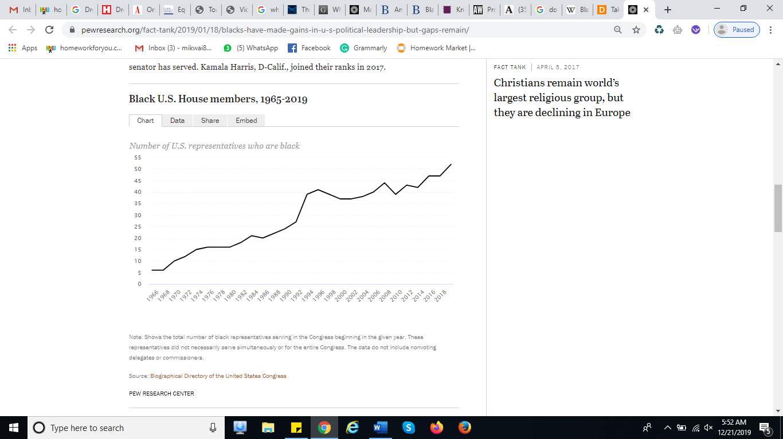
Source: https://www.pewresearch.org/fact-tank/2019/01/18/blacks-have-made-gains-in-u-s-political-leadership-but-gaps-remain/
In the economic space, labor issues culminated and evidence by numerous worker’s strike point out that there exist some challenges. In April 1968, Martin Luther king was assassinated bared because he was fighting for the ongoing inequality in the county. There were numerous riots in the cities within the country over the tragedy that had befallen the hero. The civil rights Act of 1968 was also signed into law whose role was to end housing discriminations against the black people (Pepper, 1).
Furthermore, in 1968, the Kerner commission also delivered a report titled “white racism” to the president Johnson exploring the causes of civil unrest in the African-American communities. Some of the issues suggested was dealing with pervasive discrimination on the issues of employment, education and housing. It also collected a comprehensive data addressing specific issues concerning the economic as well as social inequalities that confront the African American since 1968.
The Kerner report laid a stage for improvements of the economic status if the black people in the country. Since the report was released 50 years ago, there are clear good news as well as bad news. For instance, the black Americans are economically better off compared to the 1968 when the report was delivered to the president (Gooden, and Myers, 12).
The Africans Americans in the modern world are better educated compared to their historical beginning though they lag behind as far as overall education achievement is concerned. Close to 90 % of the younger generation of African Americans aged between 25 to 29 years are gradians describing the social progress the country has gone through.
In conclusion, pace for success among the African American is clearly set. This is evidenced by the tremendous rise in political, economic and social space in the country. Although, some hurdles may exist preventing full realization there is high chance that the equality would be attained at some point. There is need to eradicate policies, ensure justice based on ideas and legislate laws that would grant equal opportunities to all citizens of the America.

Work Cited
Carter, Prudence L., and Sean F. Reardon. "Inequality matters." William T. Grant Foundation Paper, New York: William T. Grant Foundation (2014).
Gooden, Susan T., and Samuel L. Myers. "The Kerner Commission Report Fifty Years Later: Revisiting the American Dream." RSF: The Russell Sage Foundation Journal of the Social Sciences 4.6 (2018): 1-17.
Herda, D. J. Slavery and Citizenship: The Dred Scott Case. Enslow Publishing, LLC, 2016.
Horowitz, J. Menace. Most Americans say the legacy of slavery still affects black people in the U.S. today. Pew Research Centre. (JUNE 17, 2019).Retrieved from: https://www.pewresearch.org/fact-tank/2019/06/17/most-americans-say-the-legacy-of-slavery-still-affects-black-people-in-the-u-s-today/
Pepper, William F. Orders to Kill: The Truth Behind the Murder of Martin Luther King. Skyhorse Publishing, Inc., 2015.

